DEVELOPMENT STRATEGY

**Development Strategy 3**

WBS 4

**Architecture identification 4**

Selected Architecture 4

**Stack Tecnológico 5**

Resource Plan 6

Tools and Technology 6

Resources 6

# Development Strategy

Chosen Lifecycle: Agile Continuous Delivery with DAD

I will be using the DAD Basic lifecycle according to the following diagram.

:

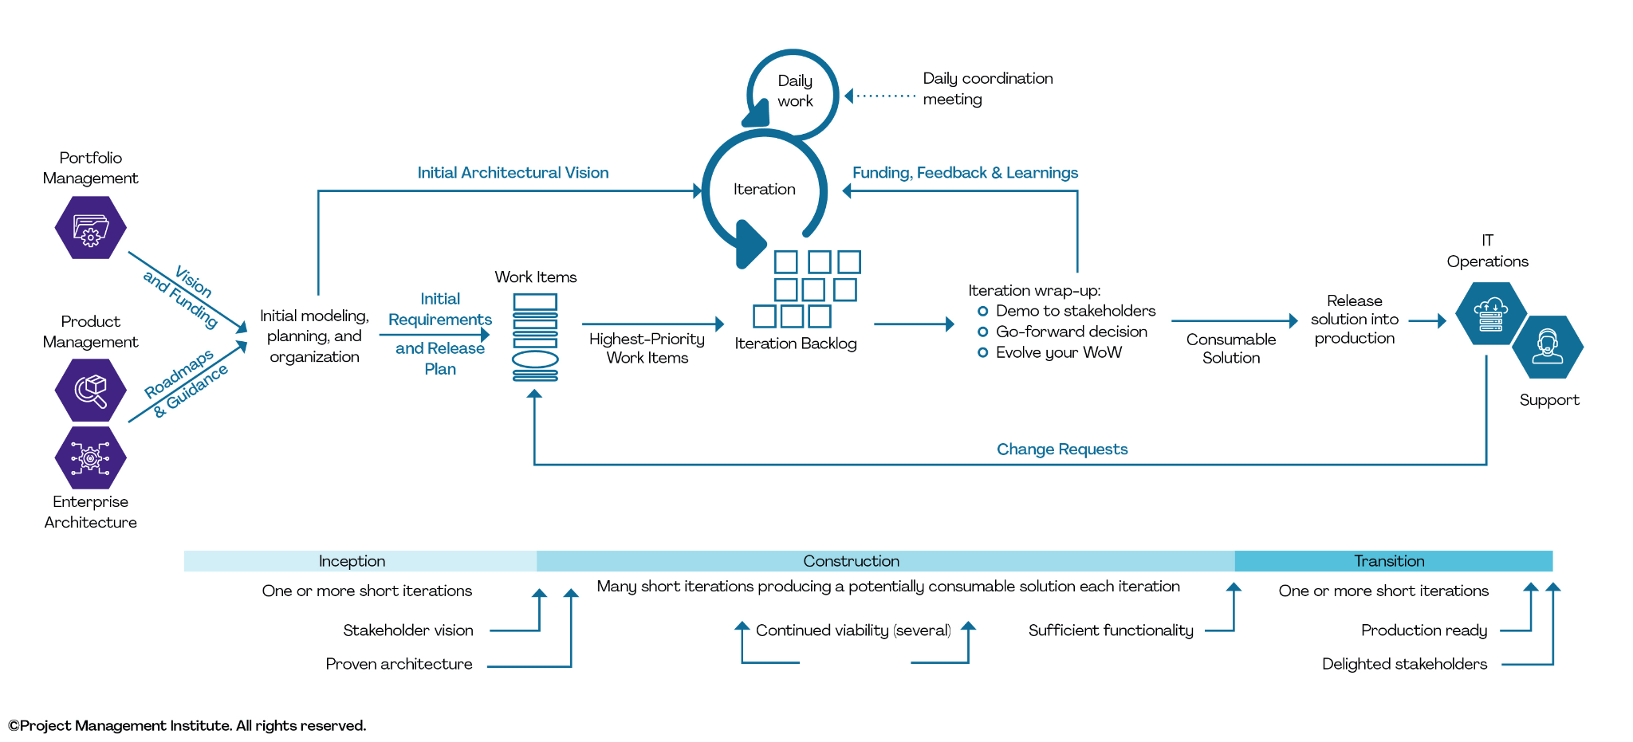

I chose this methodology because it allows me to carry out the project in iterative cycles. These cycles enable me to have common agreements with the partnering stakeholders, as well as a proven and validated architecture.

The goal of the DAD (Disciplined Agile Delivery) approach is to create a minimum viable product (MVP) of the project, which will be a version of the system with the most important functionalities. This aims to achieve customer satisfaction in a shorter timeframe and to test the system's functionality during a transition phase.

This lifecycle combines strategies and practices from various development methods, including SCRUM, XP, AM, AD, and OpenUp. Through these methods, I create an extended lifecycle based on SCRUM.

It encompasses the vision, user stories, backlog, process ownership, daily meetings, resource and document management, architecture, plans, prioritized iterations, and work activities.  
  
The lifecycle consists of three stages:

* Inception: In this stage, I plan the project to define subsequent iterations. I identify the requirements and generate the project plan or release plan to schedule the tasks, considering their priority. The goal is to generate an MVP per iteration.
* Construction: This stage involves stakeholder visions, planned architecture, short iterations with efficient solutions, continuous viability, and sufficient functionality. It is divided into iterations that aim to fulfill the most relevant requirements for the project. After each iteration, the stakeholder must accept the progress, and I make adjustments to the planning based on the lessons learned to avoid repeating the same mistakes in the following iterations. The team's way of working evolves to improve during the next iteration and achieve agile work discipline.
* Transition: This stage includes one or more short iterations to prepare the product for production and ultimately satisfy the stakeholders. It's important to note that a gradual transition takes place, allowing stakeholders to test the system in operation without replacing their current way of working. This approach prevents information loss or a sudden change that could negatively impact the company by discontinuing the use of their existing system or work methods. During this stage, it is crucial to assess stakeholder satisfaction to determine if the system has truly achieved the initially planned objectives set during the planning stage.

## WBS

[WBS of the distribution of the project](https://drive.google.com/file/d/1u-PDcoMJDwx6SsD8tPwP_9YrdBIicsoO/view?usp=sharing)

## Architecture identification

### Selected Architecture

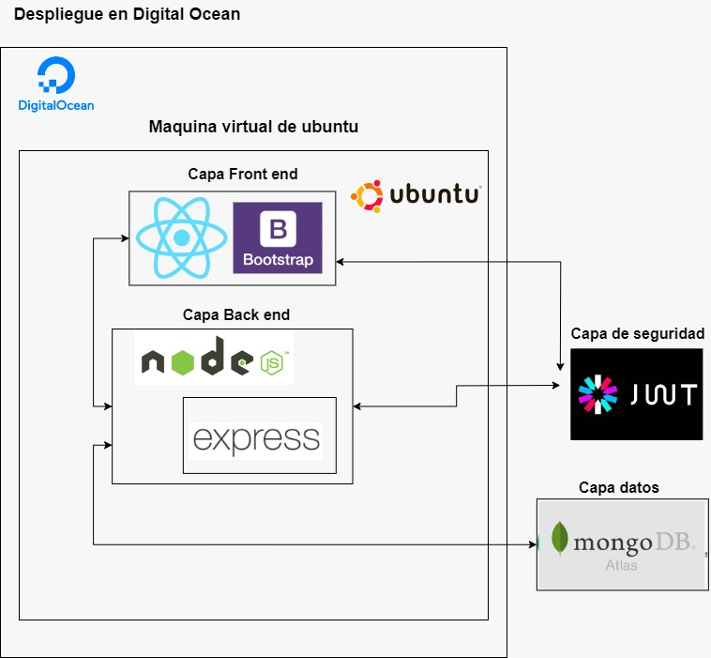

## Stack Tecnológico

| Technologies | JUSTIFICATION | DATE OF IDENTIFICATION |
| --- | --- | --- |
| React | As use of framework for front end, to facilitate development | 06/27/2023 |
| NodeJS | Back end framework previously used in other projects. | 06/27/2023 |
| Boostrap | Style framework that facilitates the design of the web application. | 06/27/2023 |
| MongoDB Atlas | Non-relational database due to the complexity of the tables. MongoDB was chosen because it can be used with Parse, a tool previously used | 06/27/2023 |
| JSON Web token | Service that provides secure access, for the creation of access tokens that allow the propagation of identity and privileges | 06/27/2023 |
| Digital Ocean | Cloud hosting. It is one of the cheapest options. | 06/27/2023 |
| Ubuntu | Operating system used to deploy in digital ocean | 06/27/2023 |

Front end.

* **React** 
  + HTML 5
  + JavaScript

Back end.

* **Node js.** 
  + JavaScript
  + Express

Style:

* **Bootstrap**

Data base.

* **Base de datos en Atlas MongoDB**
  + No relacional

Security:

* **JSON Web Token**

Deployment:

* **Digital Ocean**

Operating system

* **Ubuntu**
* Version 20.04 LTS

## Resource Plan

### Tools and Technology

| **Tools and Technology** | **Description** | **Cost** |
| --- | --- | --- |
| **Atlas Mongodb** | MongoDB database with good security | **$0 to $57 USD per month** |
| **Digital Ocean** | Deployment of the Front end, Back end and Database | **$5 to $12 USD per month** |

### Resources

| Otros | **Description** | Cost |
| --- | --- | --- |
| **Internet** | To access the system and that it can be used normally. | **$400 MXN per month** |

## 